**EXPERIMENT - 1.1**

Name: Thirumurugan V G UID: 21BCS4984

Branch: CSE Section: NTPP_IOT_602-B

Semester: 5th Date: 10-08-2023

Subject: AP Lab Subject Code: 21-CSP-314

1. **Aim:** Arrays: To implement the concept of Array.

* **Problem1:** <https://www.hackerrank.com/challenges/30-arrays/problem>
* **Problem2:** [https://www.hackerrank.com/challenges/simple-array-sum/problem](https://www.hackerrank.com/challenges/simple-array-sum/problem?isFullScreen=true)
* **Problem3:** [https://www.hackerrank.com/challenges/diagonal-difference/problem](https://www.hackerrank.com/challenges/diagonal-difference/problem?isFullScreen=true)
* **Problem4:** https://www.hackerrank.com/challenges/compare-the-triplets/problem

1. **Program Code:**

**Problem1:** Given an array, A, of N integers, print A's elements in *reverse* order as a single line of space-separated numbers.

import java.io.*;

import java.util.*;

public class Solution {

    public static void main(String[] args) {

        Scanner in = new Scanner(System.in);

        int n = in.nextInt();

        int[] arr = new int[n];

        for(int i=0; i < n; i++){

            arr[i] = in.nextInt();

        }

        in.close();

        for(int i = n - 1; i > -1; i--){

            System.out.print(arr[i] + " ");

        }

    }

}

**Problem2:** Given an array of integers, find the sum of its elements.

import java.io.*;

import java.util.*;

public class Solution {

    public static void main(String[] args) throws Exception

    {

        BufferedReader br = new BufferedReader(new InputStreamReader(System.in));

        br.readLine();

        int output=0;

        String[] input = br.readLine().split(" ");

        for(String value:input)

        {

            output += Integer.parseInt(value);

        }

        System.out.println(output);

    }

}

**Problem3:** Given a square matrix, calculate the absolute difference between the sums of its diagonals.

import java.util.Scanner;

public class DiagonalDifferernce {

    public static void main(String[] args) {

        Scanner in = new Scanner(System.in);

        int n ;

        int diag1 = 0 ; int diag2 = 0;

        n = Integer.parseInt(in.nextLine());

        for(int i =0 ; i < n; i++){

            String str[] = in.nextLine().split(" ");

            diag1 = diag1 + Integer.parseInt(str[i]);

            diag2 = diag2 + Integer.parseInt(str[n-1-i]);

        }

        int diagDiff = Math.abs(diag1 -  diag2);

        System.out.println(diagDiff);

    }

}

**Problem4:** Alice and Bob each created one problem for HackerRank. A reviewer rates the two challenges, awarding points on a scale from 1 to 100 for three categories: problem clarity, originality, and difficulty.

The rating for Alice's challenge is the triplet a = (a[0], a[1], a[2]), and the rating for Bob's challenge is the triplet b = (b[0], b[1], b[2]).

The task is to find their comparison points by comparing a[0] with b[0], a[1] with b[1], and a[2] with b[2].

If a[i] > b[i], then Alice is awarded 1 point.

If a[i] < b[i], then Bob is awarded 1 point.

If a[i] = b[i], then neither person receives a point.

import java.io.*;

import java.util.*;

public class Solution {

    public static void main(String[] args) {

        Scanner scan = new Scanner(System.in);

        int[] alice = new int[3];

        int[] bob = new int[3];

        int a=0, b=0;

        for(int i=0;i<3;i++)

            alice[i]=scan.nextInt();

        for(int i=0;i<3;i++)

            bob[i]=scan.nextInt();

        for(int i=0;i<3;i++)

            if(alice[i]>bob[i])

                a++;

            else if(alice[i]<bob[i])

                b++;

        System.out.println(a+" "+b);

        scan.close();

    }

}

1. **Output:**
2. 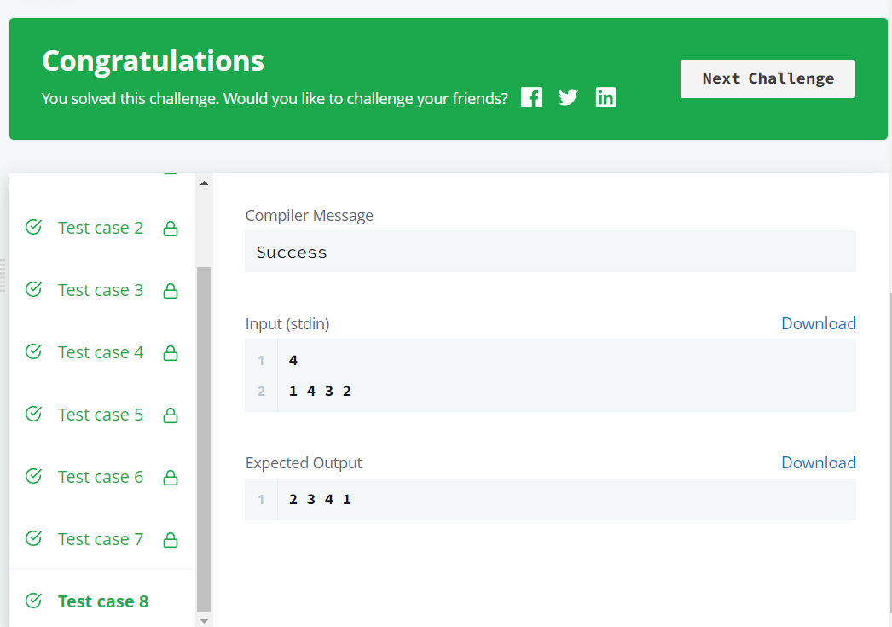
3. 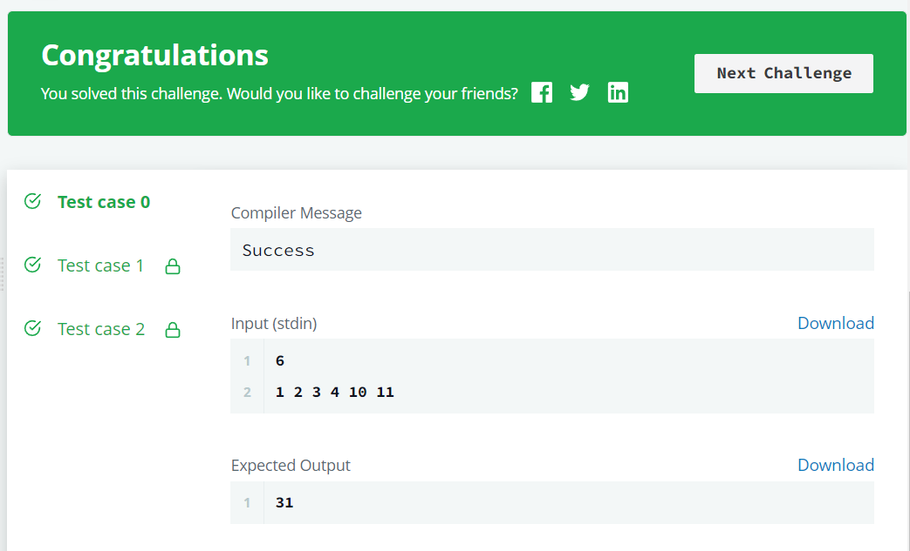
4. 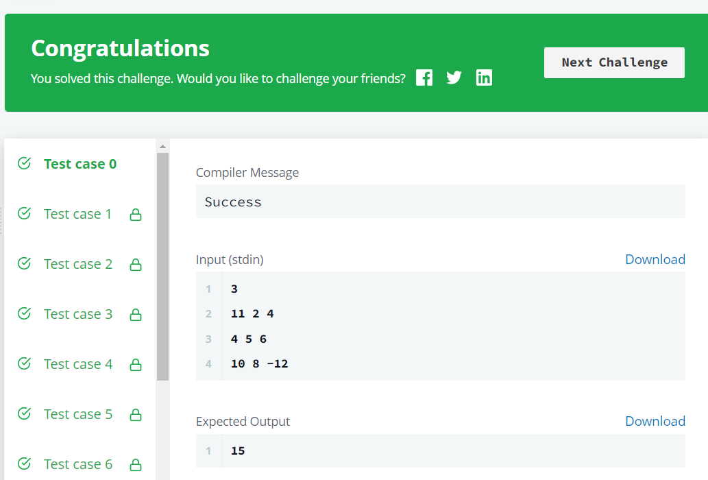
5. 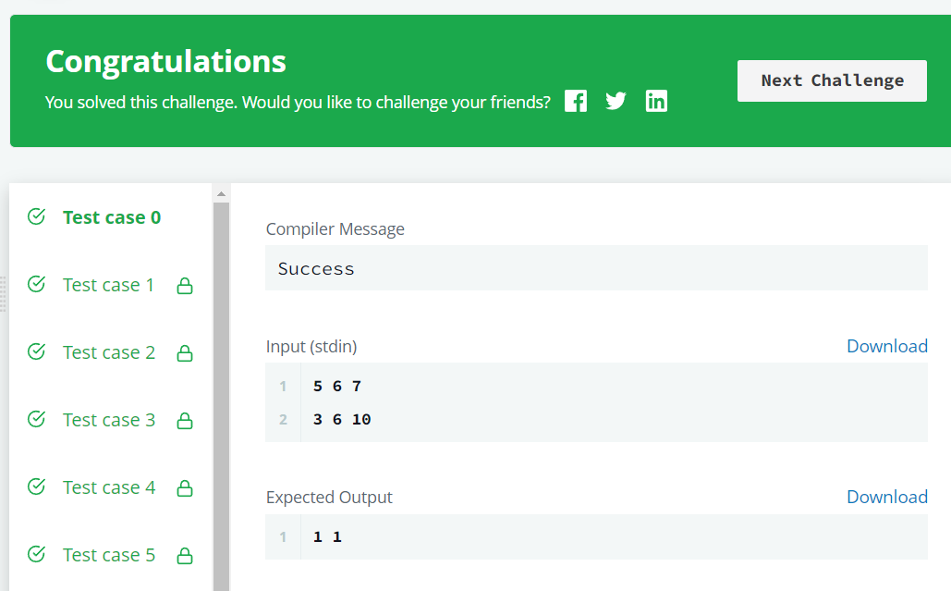
6. **Learning Outcomes:**

* The logic to find out the solution and achieve all test cases.
* Working of the function compareTriplets.
* Understand the implementation of arrays.